A MINI-PROJECT REPORT ON

**“SMART FARMING”**

SUBMITTED BY

**Ms. Kamaljit Kaur (17IT2039)**

**Mr. Piyush Jha(17IT1027)**

**Ms. Isha Gujar (17IT2042)**

Supervisor

Dr.Nikita Kulkarni



Department of Information Technology

Dr. D.Y.Patil Group’s

**Ramrao Adik Institute of Technology**

(Affiliated to University of Mumbai)

(2019)

**Certificate of Approval by Examiners**

This is to certify that the project entitled **“Smart farming”** being submitted by **Ms. Kamaljit Kaur (17IT2039) Mr. Piyush Jha(17IT1027) & Ms. Isha Gujar (17IT2042)** to the University of Mumbai in partial fulfillment of the requirement for the award of the degree of “**T.E.I.T**” in “**IOT (Mini Project) Lab**”.

**Project Guide**  **External Examiner**  **Head of Department**

(Dr. Nikita Kulkarni) ( ) ( Dr.Ashish Jadhav )

Date:

Place: Nerul, Navi Mumbai

**DECLARATION**

We declare that this written submission represents our ideas in our own words and where others' ideas or words have been included, we have adequately cited and referenced the original sources. We also declare that we have adhered to all principles of academic honesty and integrity and have not misrepresented or fabricated or falsified any idea/data/fact/source in our submission. We understand that any violation of the above will because for disciplinary action by the Institute and can also evoke action from the sources which have thus not been properly cited or from whom proper permission has not been taken when needed.

**Name and Roll No. of Students Signature**

Ms. Kamaljit Kaur (17IT2039)

Mr. Piyush Jha(17IT1027)

Ms. Isha Gujar (17IT2042)

Date:

Place: Ramrao Adik Institute of technology

**PREFACE**

We take great opportunity to present this Mini Project report on “**Smart-Farming**” and put before readers some useful information regarding our project. We have made sincere attempts and taken every care to present this matter in precise and compact form, the language being as simple as possible. We are sure that the information contained in this volume certainly prove useful for better insight into the scope and dimension of this project in its true perspective.

The task of the completion of the project though being difficult was made quite simple, interesting and successful due to deep involvement and complete dedication of our group members.

**TABLE OF CONTENTS**

Sr.No Topic Pg.no

Declaration …………….…….………………………………………………………………I

Acknowledgement……...……………………………………………………………………II

Preface…………….…………………………………………………………………………III

Table of Contents………………………………………………….………………………....IV

Table of figures...…………………………………………………………………………….V

Abstract…....………………………………………………….……………………………...VI

1.INTRODUCTION…………………………………………………………………………..8

1.1.IOT INTRODUCTION, CHARACTERISTICS

AND 6A CONNECTIVITY……………………………………….…………………....8

1.2PROBLEMSTATEMENT……………………………………………………………....12

1.3OBJECTIVES…………………………………………………………………………..13

2.LITERATURE SURVEY ………………………………………………………………....14

2.1MOTIVATION…………………………………………………………………………15

3.PROPOSED SYSTEM …………………………………………………………………...16

3.1INTRODUCTION OF PROPOSED SYSTEM AND

ARCHITECTURE…………………………………………………………………………..16

3.2HARDWAREANDSOFTWAREREQUIREMENTS………………………………….17

4.IMPLEMENTATION……………………………………………………………………...21

4.1CIRCUIT DIAGRAM USING SIMULATOR…………………………………………21

4.2 CONNECTION DETAILS………………………………………………………………22

4.3 CODE………………………………………………………………………………..…..26

5.RESULT…………………………………………………………………………………….36

6.CONCLUSION AND FUTURE SCOPE……………………………………………..……37

6.1 CONCLUSION…......………………………………………………………………..….37

6.2 FUTURESCOPE……………………………………………………………………..….37

6.3BENEFITS TO SOCIETY……………………………………………………………….38

7.REFERENCES………………………………………………………………………..…….47

**TABLE OF FIGURES**

|  |  |  |
| --- | --- | --- |
| SR.NO | Name of Figure | Page No |
| 1 | Raspberry PI | 8 |
| 2 | DHT11 temperature sensor | 8 |
| 3 | MQ2 smoke sensor | 9 |
| 4 | Soil moisture sensor | 10 |
| 5 | Web camera | 11 |
| 6 | Model picture | 14 |
| 7 | Model picture | 14 |

**ABSTRACT**

Agriculture is the broadest economic sector and plays an important role in the overall economic development of a nation. Technological advancements in the arena of agriculture will ascertain to increase the competence of certain farming activities. In this project, we have proposed a novel methodology for smart farming by linking a smart sensing system and smart irrigator system through wired & wireless communication technology. Our system focuses on the measurement of physical parameters such as soil moisture content, nutrient content, and pH of the soil that plays a vital role in farming activities. Based on the essential physical and chemical parameters of the soil measured, water is splashed on the crops using a water pumping motor. The detailed modelling and control strategies of a smart farming system are demonstrated in this project.

**1.1 INTRODUCTION TO IOT**

Today, Internet application development demand is very high. So IoT is a major technology by which we can produce various useful internet applications.

Basically, IoT is a network in which all physical objects are connected to the internet through network devices or routers and exchange data. IoT allows objects to be controlled remotely across existing network infrastructure. IoT is a very good and intelligent technique which reduces human effort as well as easy access to physical devices. This technique also has autonomous control feature by which any device can control without any human interaction.

“Things” in the IoT sense, is a mixture of hardware, software, data, and services. “Things” can refer to a wide variety of devices such as DNA analysis devices for environmental monitoring, electric clamps in coastal waters, Arduino chips in home automation and many others. These devices gather useful data with the help of various existing technologies and share that data between other devices. Examples include Home Automation System which uses Wi-Fi or Bluetooth for exchange data between various devices of home.

**CHARACTERISTICS OF IOT**

### INTELLIGENCE

Together algorithms and compute (i.e. software & hardware) provide the “intelligent spark” that makes a product experience smart. Consider Misfit Shine, a fitness tracker, compared to Nest’s intelligent thermostat. The Shine experience distributes compute tasks between a smartphone and the cloud. The Nest thermostat has more compute horsepower for the AI that makes them smart.

### CONNECTIVITY

Connectivity in the IoT is more than slapping on a Wi-Fi module and calling it a day. Connectivity enables network accessibility and compatibility. Accessibility is getting on a network while compatibility provides the common ability to consume and produce data. If this sounds familiar, that’s because it is Metcalfe’s Law and it rings true for IoT.

### SENSING

We tend to take for granted our senses and ability to understand the physical world and people around us. Sensing technologies provide us with the means to create experiences that reflect a true awareness of the physical world and the people in it. This is simply the analogy input from the physical world, but it can provide a rich understanding of our complex world.

### EXPRESSING

Expressing enables interactivity with people and the physical world. Whether it is a smart home or a farm with smart agriculture technology, expressing provides us with a means to create products that interact intelligently with the real world. This means more than just rendering beautiful UIs to a screen. Expressing allows us to output into the real world and directly interact with people and the environment.

### ENERGY

Without energy we can’t bring our creations to life. The problem is we can’t create billions of things that all run on batteries. Energy harvesting, power efficiency, and charging infrastructure are necessary parts a power intelligent ecosystem that we must design. Today, it is woefully inadequate and lacks the focus of many product teams.

### SAFETY

As we gain efficiencies, novel experiences, and other benefits from the IoT, we must not forget about safety. As both the creators and recipients of the IoT, we must design for safety. This includes the safety of our personal data and the safety of our physical well-being. Securing the endpoints, networks, and the data moving across all of it means creating a security paradigm that will scale.

**1.2 Problem Statement:**

Smart Farming is a farming management concept using modern technology to increase the quantity and quality of agricultural products.By precisely measuring variations within a field and adapting the strategy accordingly, farmers can greatly increase the effectiveness of pesticides and fertilizers, and use them more selectively. Similarly, using Smart Farming techniques, farmers can better monitor the needs of individual animals and adjust their nutrition correspondingly, thereby preventing disease and enhancing herd health.We believe that our concept will be a benchmark in the agribusiness due to its reliability and remote monitoring. Our idea tries to digitize farming and agricultural activities so that the farmers can check on the requirements of the crops and accurately predict their growth. This concept will surely accelerate their business to reach new heights and also be more profitable. The implementation of our project largely depends upon the awareness among farmers, which we believe will be easily created due to its numerous advantages.

**1.3 Objectives**

## 1. To design a system to reduce manual efforts.

## 2. Develop fast sensing mechanism.

## 3. Make use of knowledge of IOT sensing in solving social problems.

## 4. To have an easy to use, time saving approach.

## 5.To make knowledge of the current environmental conditions.

## 6. To monitor the farm using Web-camera.

7. To detect fire or any false smoke in the farm.

**2.Literature Survey**

1.Affordable Smart Farming Using IoT and Machine Learning

Author:Reuben Varghese & Smarita Sharma

This project automates the monitoring of crops thereby reducing human intervention but there are also some limitations to uneducated farmers.

2.Providing Smart Agricultural solutions to farmers for better yielding using IoT

Author:M.K Gayatri,J Jayashakhti & G.S.Anandha Mala

This project uses the combination of IoT and cloud computing but there is no active internet connection at the rural areas to connect to the cloud.

3.Big Data in Smart Farming

Author:Marc-Jeroen Bogaardt

This project is real-time assisting reconfiguration features but it requires trained professions to make any chances.

4.Smart Farming and solar technology

Author:Anand Nayyar & Dr. Vikram Puri

This project provides an eco-friendly solution but on the other hand,solar installations are expensive

5.Smart Farming and Food Safety

Author:Aioti-Alliance for Internet of Things

This project is promoting healthy and safer livestock and agricultural products but educating the farmers to reduce the use of chemicals.

**2.1 MOTIVATION**

Our smart farming system will be more advanced than other ordinary systems, in case of fire in farm. The notification will be sent to the owner of the house for security and an email will be sent to the owner. Due to which help will reach quickly and situations can be handled immediately. It shares the information related pH, temperature & humidity etc by machine learning prediction algorithms and will help analyse the situation in future. Any intruder tries to enter the farm, buzzer will get on and notifications will be sent to the farmer.

**PROPOSED SYSTEM**

**3.1 Introduction to proposed system and architecture**

Smart Farming is a hi-tech and effective system of doing agriculture and growing food in a sustainable way. It is an application of implementing connected devices and innovative technologies together into agriculture. Smart Farming majorly depends on IoT thus eliminating the need of physical work of farmers and growers and thus increasing the productivity in every possible manner. We need to interface the raspberry pi with the various sensors and get started with the project. The management of these sensors can all be done in a control room to avoid interference with the regular farm activities.The Farm monitoring system created by us is an effort to overcome all the problems existing in the systems that exist in the market today. The proposed system collects data from soil moisture sensor, LDR sensor and Temperature sensor. These sensors provide information to the Raspberry PI and at the same time. The system checks whether the water tank is dry or temperature has been increased and starts the motor accordingly.

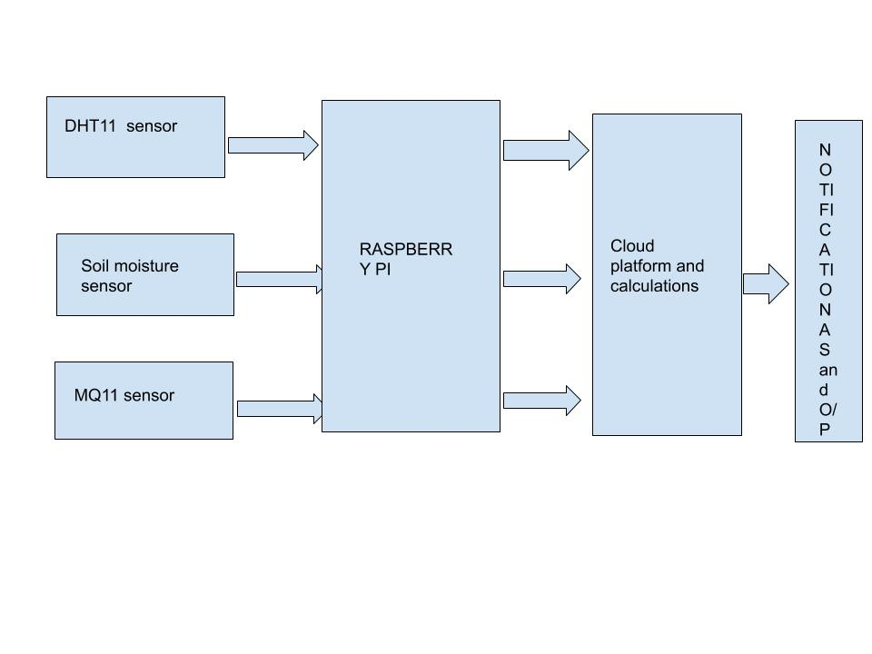Fig 3.1.Flow of project

**3.2 HARDWARE AND SOFTWARE REQUIREMENTS**

1. Raspberry Pi module:

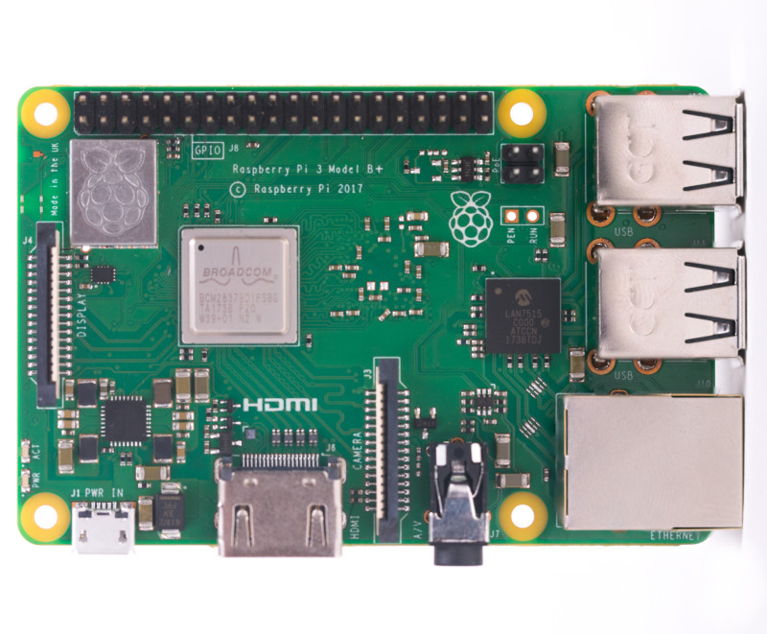

Fig 3.2.1

The Pi 3 Model B+ has a 1.4GHz 64-bit quad-core Broadcom Arm Cortex A53-architecture processor compared with the Raspberry Pi 3 Model B's 1.2GHz CPU. ... It also supports dual-band wireless local-area networks at 2.4GHz and 5GHz, Bluetooth 4.2, and Bluetooth Low Energy.

1. DHT11 temperature sensor

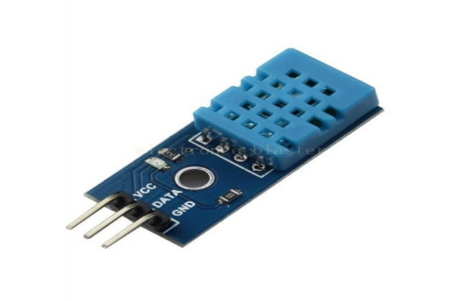

Fig.3.2.2

Pin details:(-)GND,(+)Vcc,output

This module integrates DHT11 sensor and other required components on a small PCB. The DHT11 sensor includes a resistive-type humidity measurement component, an NTC temperature measurement component and a high-performance 8-bit microcontroller inside, and provides calibrated digital signal output. It has high reliability and excellent long-term stability, thanks to the exclusive digital signal acquisition technique and temperature & humidity sensing technology.

3.MQ2 gas sensor

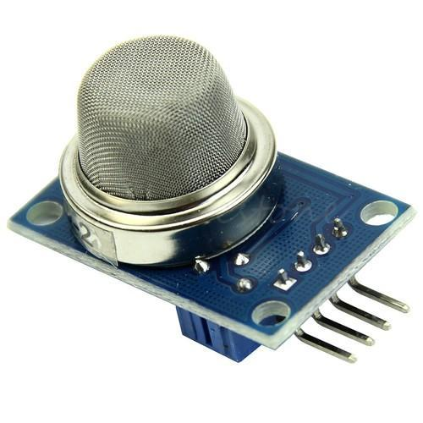

Fig 3.2.3

Pin details:(-)GND,(+)Vcc,output-Input

The Grove - Gas Sensor(MQ2) module is useful for gas leakage detection (home and industry). It is suitable for detecting H2, LPG, CH4, CO, Alcohol, Smoke or Propane. Due to its high sensitivity and fast response time, measurement can be taken as soon as possible. The sensitivity of the sensor can be adjusted by potentiometer.

4.Soil moisture Sensor

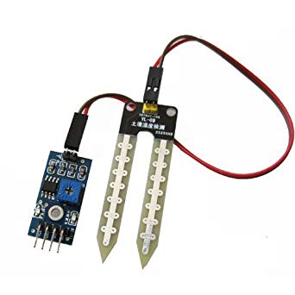

Fig 3.2.4

Pin details:(-)GND,(+)Vcc

Soil moisture sensor consists of two conducting plates which function as a probe and acting as a variable resistor together.When the sensor is inserted into the water, the resistance will decrease and get better conductivity between plates.

5.Buzzer module

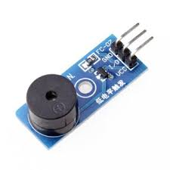

Fig 3.2.5

Pin details:(-)GND,(+)Vcc,output-Input

A 5V Active Alarm Buzzer Module for Arduino is an audio signaling device, which may be mechanical, electromechanical, or piezoelectric. Just like what you are viewing now, it is 5V DC Electronic Part Active Buzzer Module.

6.Connecting wires

7.Breadboard for connection

8.Blynk cloud platform

9.Web Camera

**4.2 CONNECTION DETAILS:**

In this project,the three sensors used namely Temperature,Soil Moisture & Gas Sensors are connected GPIO PIN 27,17 & 2 respectively.The DHT11 sensor is connected to the RPi takes in the temperature from the surrounding. We have applied ML algorithm to it to predict the conditions of the weather based on this reading. MQ2 and soil moisture are also connected to the raspberry PI and thus monitor the farm activities.The data is sent to Blynk Cloud which is further used to notify the farmer if there is any presence of gas(fire) and if there is sufficient quantity of water in the water tank.Rest the Vcc is connected to 3.3V & ground is connected to GND pin.

**4**.**3 CODE**:

import RPi.GPIO as GPIO

import time

import urllib2

import json

import time

import Adafruit_DHT

from sklearn import linear_model

##import matplotlib.pyplot as plt

from sklearn import preprocessing

import pandas as pd

import blynklib

pin=27

GPIO.setmode(GPIO.BCM)

GPIO.setwarnings(False)

GPIO.setup(2,GPIO.IN) #gas

GPIO.setup(27,GPIO.IN) #temperature DHT11

GPIO.setup(17,GPIO.IN) #soil

#GPIO.setup(27,GPIO.IN)ultrasonic

sensor = Adafruit_DHT.DHT11

df=pd.read_csv("Weather3.csv")

X = df[['HUMIDITY', 'TEMPERATURE']]

y = df['WEATHER FORECAST']

reg = linear_model.LinearRegression()

reg.fit(df[['HUMIDITY', 'TEMPERATURE']], df['WEATHER FORECAST'])

BLYNK_AUTH='MFm4vv9TsmdTdpYrMvWLOFShmVkyfN1I'

blynk=blynklib.Blynk(BLYNK_AUTH)

'''def sendNotification(token, channel, message):

data = {

"body" : message,

"message_type" : "text/plain"

}

req = urllib2.Request('http://api.pushetta.com/api/pushes/{0}/'.format(channel))

req.add_header('Content-Type', 'application/json')

req.add_header('Authorization', 'Token {0}'.format(token))

response = urllib2.urlopen(req, json.dumps(data))'''

i=0

while(True):

print("REPORT NO: ",i)

i=i+1

x=GPIO.input(2)

y=GPIO.input(17)

if x==0 and y==0 :

print("gas detected")

print("Water Detected")

try:

blynk.run()

print("Reading PIR status")

#sendNotification("7f6fc5b7b41bebf3a92c0f92eef4272054eed27b", "piyush5", "EMERGENCY !!! \n Your farm is on Fire ")

blynk.notify('EMERGENCY !!! \n Your farm is on Fire')

print("Fire Detected")

except KeyboardInterrupt:

print("Exit")

GPIO.cleanup()

elif x==0 and y==1:

print("gas present")

try:

print("Reading PIR status")

#sendNotification("7f6fc5b7b41bebf3a92c0f92eef4272054eed27b", "piyush5", "Your Farm is On Fire /n Water Level is also Decreased ")

blynk.notify('Your farm is on Fire /n Water Level is also Decreased ')

print("fire")

except KeyboardInterrupt:

print("Exit")

GPIO.cleanup()

elif x==1 and y==0:

print("All is well! xD")

elif x==1 and y==1:

try:

print("11111111Reading PIR status")

#sendNotification("7f6fc5b7b41bebf3a92c0f92eef4272054eed27b","piyush5","Alert!! no water for farming\n switch on the irrigation system")

blynk.notify('Alert!! no water for farming\n switch on the irrigation system')

print("no water")

except KeyboardInterrupt:

print("Exit")#

GPIO.cleanup()

time.sleep(10)

#GPIO.output(3,GPIO.LOW)

#GPIO.output(27,GPIO.LOW)

#machinelearning:

else:

print("sensor not working")

while (True):

# Try to grab a sensor reading. Use the read_retry method which will retry up

# to 15 times to get a sensor reading (waiting 2 seconds between each retry).

humidity, temperature = Adafruit_DHT.read_retry(sensor, pin)

# Note that sometimes you won't get a reading and

# the results will be null (because Linux can't

# guarantee the timing of calls to read the sensor).

# If this happens try again!

if humidity is not None and temperature is not None:

print('Temp={0:0.1f}*C Humidity={1:0.1f}%'.format(temperature, humidity))

fahrenheit=float((temperature*1.8)+32) #formula

X = df[['HUMIDITY', 'TEMPERATURE']]

y = df['WEATHER FORECAST']

le = preprocessing.LabelEncoder()#making LabelEncoder function varibale

df = df.apply(le.fit_transform)#this is used to convert string values into integer values

reg = linear_model.LinearRegression()

reg.fit(df[['HUMIDITY', 'TEMPERATURE']], df['WEATHER FORECAST'])

print("WEATHER REPORT")

print(reg.predict([[humidity,fahrenheit]]))

if(float(reg.predict([[humidity,fahrenheit]]))>=0 and float(reg.predict([[humidity,fahrenheit]]))<1):

try:

#sendNotification("7f6fc5b7b41bebf3a92c0f92eef4272054eed27b", "piyush5", "light rain ")

blynk.notify('Light rain')

print("light rain")

except KeyboardInterrupt:

print("Exit")

GPIO.cleanup()

elif(float(reg.predict([[humidity,fahrenheit]]))>=1 and float(reg.predict([[humidity,fahrenheit]]))<2):

try:

#sendNotification("7f6fc5b7b41bebf3a92c0f92eef4272054eed27b", "piyush5", "Broken Clouds ")

blynk.notify('Broken Clouds')

print("Broken Clouds")

except KeyboardInterrupt:

print("Exit")

GPIO.cleanup()

elif (float(reg.predict([[humidity, fahrenheit]]))>=2 and float(reg.predict([[humidity, fahrenheit]])) < 3):

try:

#print("Reading PIR status")

#sendNotification("7f6fc5b7b41bebf3a92c0f92eef4272054eed27b", "piyush5", "Proximity Shower Rain ")

blynk.notify('Proximity Shower Rain')

print("Proximity Shower Rain ")

except KeyboardInterrupt:

print("Exit")

GPIO.cleanup()

elif (float(reg.predict([[humidity, fahrenheit]]))>=3 and float(reg.predict([[humidity, fahrenheit]])) < 4):

try:

#print("Reading PIR status")

#sendNotification("7f6fc5b7b41bebf3a92c0f92eef4272054eed27b", "piyush5", "Sky is Clear ")

blynk.notify('Sky is Clear')

print("Sky is Clear")

except KeyboardInterrupt:

print("Exit")

GPIO.cleanup()

elif (float(reg.predict([[humidity, fahrenheit]]))>=4 and float(reg.predict([[humidity, fahrenheit]])) < 5):

try:

#print("Reading PIR status")

#sendNotification("7f6fc5b7b41bebf3a92c0f92eef4272054eed27b", "piyush5", "Scattered Clouds")

blynk.notify('Scattered Clouds"')

print("Scattered Clouds")

except KeyboardInterrupt:

print("Exit")

GPIO.cleanup()

elif (float(reg.predict([[humidity, fahrenheit]])) >= 5 and float(reg.predict([[humidity, fahrenheit]])) < 6):

try:

#print("Reading PIR status")

#sendNotification("7f6fc5b7b41bebf3a92c0f92eef4272054eed27b", "piyush5", "Few Clouds ")

blynk.notify('Few Clouds')

print("Few Clouds")

except KeyboardInterrupt:

print("Exit")

GPIO.cleanup()

elif (float(reg.predict([[humidity, fahrenheit]])) >= 6 and float(reg.predict([[humidity, fahrenheit]])) < 7):

try:

#print("Reading PIR status")

#sendNotification("7f6fc5b7b41bebf3a92c0f92eef4272054eed27b", "piyush5", "Squalls ")

blynk.notify('Squalls')

print("Squalls")

except KeyboardInterrupt:

print("Exit")

GPIO.cleanup()

elif (float(reg.predict([[humidity, fahrenheit]])) >= 7 and float(reg.predict([[humidity, fahrenheit]])) < 8):

try:

#print("Reading PIR status")

#sendNotification("7f6fc5b7b41bebf3a92c0f92eef4272054eed27b", "piyush5", "Overcast Clouds ")

blynk.notify('Overcast Clouds')

print("Overcast clouds ")

except KeyboardInterrupt:

print("Exit")

GPIO.cleanup()

elif (float(reg.predict([[humidity, fahrenheit]])) >= 8 and float(reg.predict([[humidity, fahrenheit]])) < 9):

try:

#print("Reading PIR status")

#sendNotification("7f6fc5b7b41bebf3a92c0f92eef4272054eed27b", "piyush5", "Heavy Snow ")

blynk.notify('Heavy Snow')

print("Heavy Snow")

except KeyboardInterrupt:

print("Exit")

GPIO.cleanup()

elif (float(reg.predict([[humidity, fahrenheit]])) >= 9 and float(reg.predict([[humidity, fahrenheit]])) < 10):

try:

#print("Reading PIR status")

#sendNotification("7f6fc5b7b41bebf3a92c0f92eef4272054eed27b", "piyush5", "Mist")

blynk.notify('Mist')

print("Mist")

except KeyboardInterrupt:

print("Exit")

GPIO.cleanup()

elif (float(reg.predict([[humidity, fahrenheit]])) >= 10 and float(reg.predict([[humidity, fahrenheit]])) < 11):

try:

#print("Reading PIR status")

#sendNotification("7f6fc5b7b41bebf3a92c0f92eef4272054eed27b", "piyush5", "Haze ")

blynk.notify('Haze')

print("Haze")

except KeyboardInterrupt:

print("Exit")

GPIO.cleanup()

elif (float(reg.predict([[humidity, fahrenheit]])) >= 11 and float(reg.predict([[humidity, fahrenheit]])) < 12):

try:

#print("Reading PIR Status")

#sendNotification("7f6fc5b7b41bebf3a92c0f92eef4272054eed27b", "piyush5", "Fog")

blynk.notify('Fog')

print("Fog")

except KeyboardInterrupt:

print("Exit")

GPIO.cleanup()

else:

print("not predicted")

else:

print('Failed to get reading. Try again!')

time.sleep(10)

break

**5.RESULT**:

1.Complete circuit of project

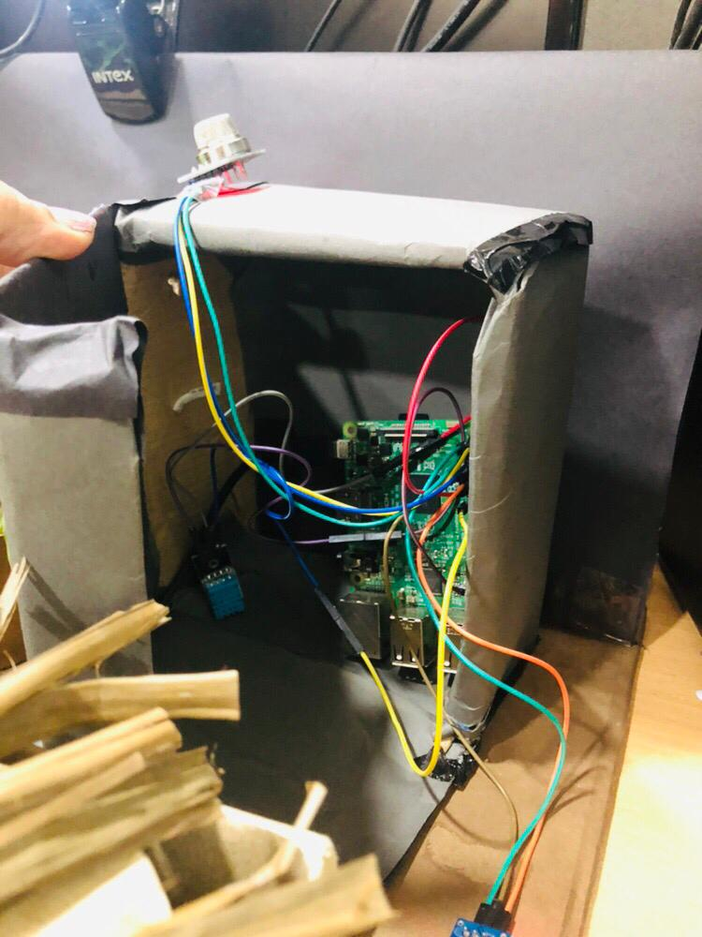

Fig 5.1(Complete circuit of project)

**DETAILS**:MQ2 Gas sensor -GPIO pin no.2,

Soil and Moisture sensor -GPIO pin no.27

Temperature sensor -GPIO pin no.17

2.Result of project

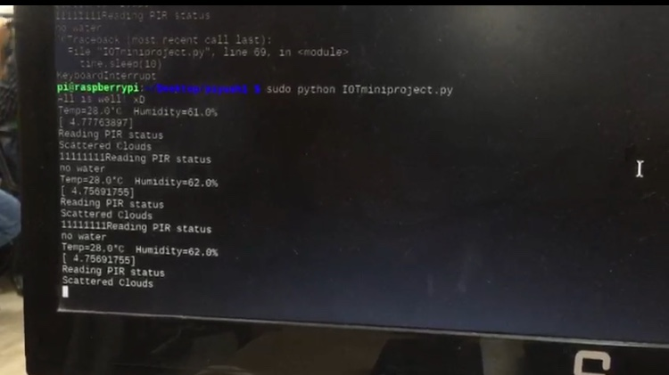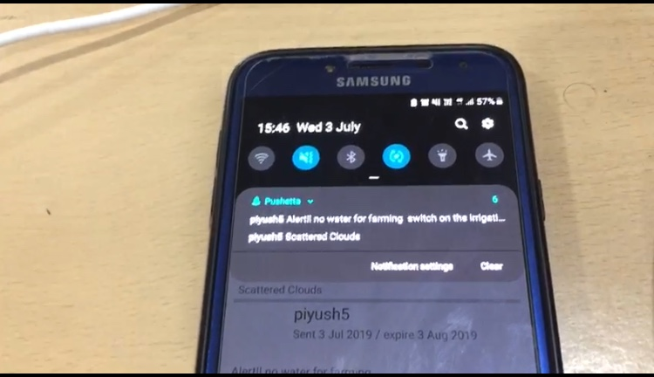

Fig 5.2(Result of project)

**Details**: Fire,irrigation and weather prediction is shown on python IDLE and corresponding message is notify on phone.

3.Complete model of Smart Farming project

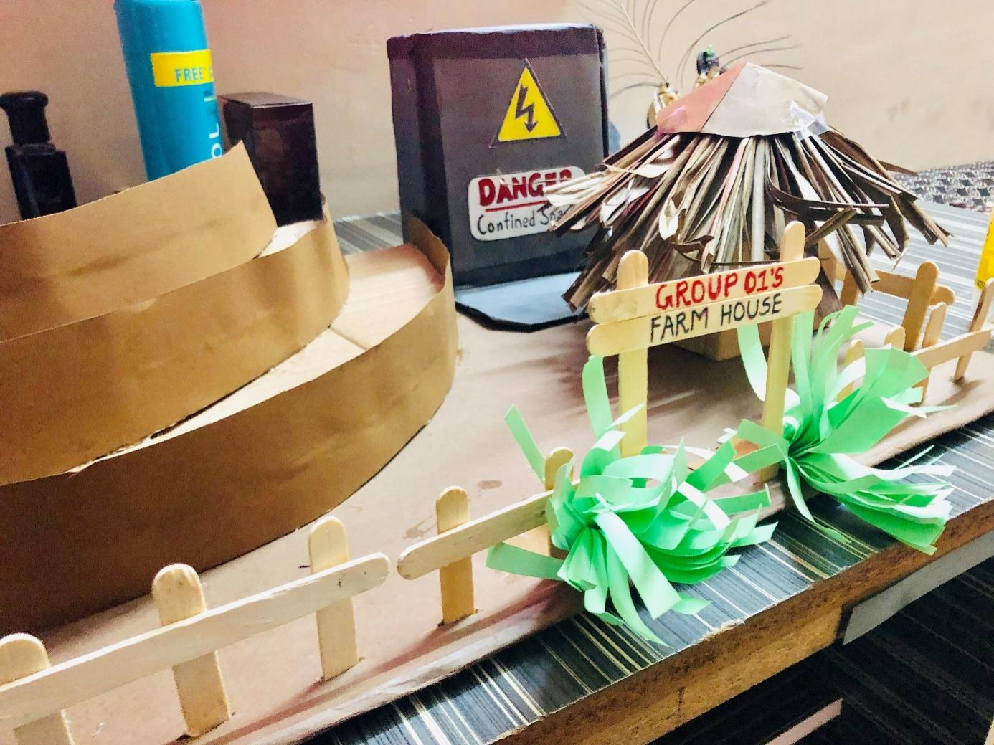

Fig 5.3(Complete model of Smart Farming project)

**Details:** Complete model of Smart farming project. Danger room contain complete circuit of project.Left side is our farm. MQ2 gas sensor is embedded on the top of danger room.Water tank is placed adjacent to danger room

**6. CONCLUSION AND FUTURE SCOPE**

**6.1 CONCLUSION**

Thus, IOT agricultural applications are making it possible for farmers to collect meaningful data. Large landowners and small farmers must understand the potential of smart technologies to increase competitiveness and sustainability in their productions.The demand for growing population can be successfully met if farmers implement agricultural IOTsolutions in a successful manner. With this simple system, we aimed to make a farmer's life simpler and easier. With the use of latest open source controllers, we learned that upgrading ourselves with time not only saves time but also teaches us about the need of advancements.

**6.2 FUTURE SCOPE**

The system aimed at providing the common farmer with an effective low-cost monitoring circuit so that he could have productive yields. Though the cost of the circuit is moderate, with advancements it could be effectively minimized so that it could be used in every next farm. The power consumption of the Farm monitoring circuit is not taken into account yet. However, with the use of effective equipment and use of integrated circuit technology the power consumption of the automation board could be minimized to a very large extent. These of integrated circuit technology will not only minimize the power consumption but also reduce the circuit size effectively. With future research and development, the circuit could be designed to meet the needs of the farmers. Also with the integration of multiplexers, Demultiplexers and other digital circuits, the restriction on the number of sensor parameters that could be used with the monitoring circuit could be eliminated.

**6.3 BENEFITS TO SOCIETY**

1**.**Makes the farming practice more controlled and accurate using various items like sensors, control systems, robotics, autonomous vehicles and automated hardware.

2.Allows farmers to maximize yields using minimal resources such as water, fertilizer, and seeds.

3.Remote farm monitoring.

**7. REFERENCES**

[1] Patil, V. C., Al-Gaadi, K. A., Biradar, D. P., &Rangaswamy, M. (2012). Internet of Things (IOT) and cloud computing for agriculture: An overview. Proceedings of Argo-Informatics and Precision Agriculture (AIPA 2012), India, 292-296.

[2]C. Peng, "Development strategy research based on the internet of things in smart agriculture", Journal of Xi'an University of Post and telecommunications, vol. 17, no. 2, pp. 94-98, 2012.

[3]Dr.V. VidyaDevi,G. Meena Kumari, “Real- Time Automation and Monitoring System for Modernized Agriculture” ,International Journal of Review and Research in Applied Sciences and Engineering (IJRRASE) Vol3 No.1. PP 7-12, 2013

[4]Chetan Dwarkani M, Ganesh Ram R, Jagannathan S, R.Priyatharshini, “Smart Farming System Using Sensors for Agricultural Task Automation”, IEEE International Conference on Technological Innovations in ICT for Agriculture and Rural Development (TIAR 2015).

[5][https://www.geeksforgeeks.org/crop-monitoring-smart-farming-using-iot](https://www.geeksforgeeks.org/crop-monitoring-smart-farming-using-iot/)

[6]Ashton, K. (2009). That ‘internet of things’ thing. RFiDJournal, 22(7), 97-114.

[7]Atzori, L., Iera, A., & Morabito, G. (2010). The internet of things: A survey.Computer networks, 54(15), 2787-2805.